

IB Coordinators Lunch & Learn Notes, December 12, 2024
Hello, amazing IB Coordinators! Here are the Summary Notes and resources links from our December IB Coordinators Lunch & Learn. Our theme for 2024-2025 is IB Dreams to Action through the lens of BELONGING.
(Click on the links and images throughout the notes to access more information.)
Thank you to everyone who was able to join in our IBCs Lunch & Learn and contribute to wonderful, collaborative thinking using this provocation, How can an inquiry-based approach to teaching create learning experiences that make everyone feel that they belong?
  We inquired into Establishing belonging through inquiry with an IB Sketchnote and emphasized IB educators are Social Entrepreneurs. We looked at, A Crisis of Student Belonging’s statements about What is School Connectedness?, What is a “Sense of Belonging”?, and How is Belonging Nurtured in the Classroom? | 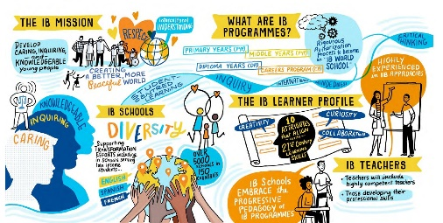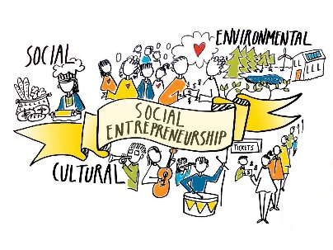  Where do we see BELONGING in IB?  “An education that is focused on inquiry invites all students to engage and belong in the learning experience. Many of the traditional ways of doing school do not work for a majority of students. Teachers are the single greatest factor in ensuring a successful transition from traditional pedagogy to the adoption of inquiry in our classrooms.” -IB
  We looked at Visible Learning: Inquiry-based teaching and  Programme standards and practices for Learning on My IB | -“nearly 40 percent of high school student in the U.S. do not feel close to people at school.”  Edweek quote from the CDC  -Inquiry-based teaching has the potential to considerably accelerate student achievement  -Programme standards and practices Learning 04  Coherent curriculum 1.6, Approaches to teaching 1, Approaches to teaching 1.1
  How to Cultivate Belonging: Shifts and Strategies for Teachers | “Learning communities in IB World Schools engage in cycles of inquiry, action and reflection that lead to deeper understanding and a lifetime of learning. (Programme standards and practices)
  We reflected on Cultures of Thinking Mindset 4 and used Values, Identities, Actions Thinking Routine to explore thoughts, people, and actions.  The IB’s research study on inquiry-based teaching and learning presented possible actions to explore further on our own. | “Relationships serve to motivate and engage us. They provide a supportive context for taking risks. (Ron Ritchhart)  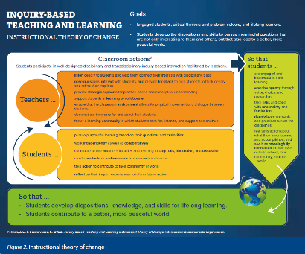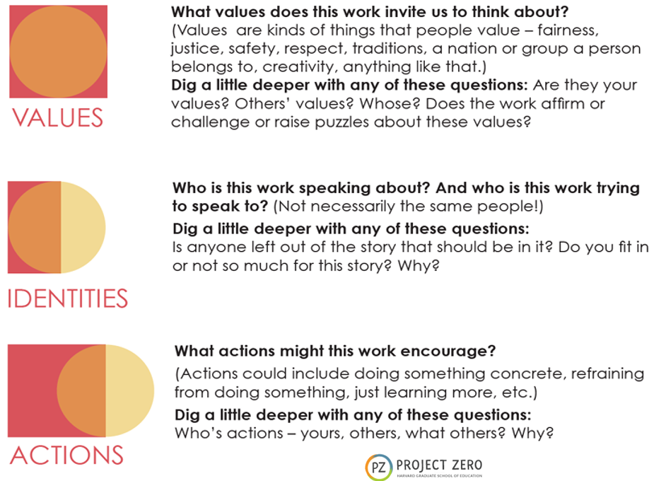  Meanings and practices of inquiry-based teaching and learning in the IB

Table Groups Presented a graphic plan for creating a sense of belonging using an inquiry-based approach to teaching and learning.
Cultures of Thinking 10 Transformative Mindsets - A resource for planning
